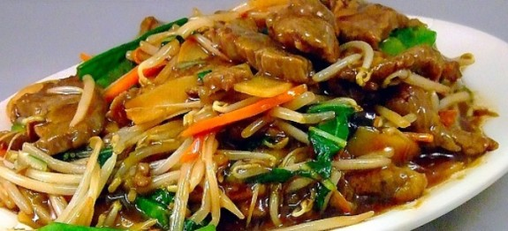

**Vegetable Chopsuey**

**Ingredients:**

* 1/2 cup carrots-shredded fine
* 1 cup cabbage-shredded fine
* 1/2 cup capsicums-shredded fine
* 1/2 cup onions-sliced thin
* 2 tsp garlic-chopped fine
* 2 tbsp oil
* 200 gm noodles-boiled and drained well
* 2 tbsp vinegar
* 1/2 tsp Soya sauce
* 1 tsp sugar
* salt to taste
* 2 tbsp cornflour
* oil to deep fry noodle

**Method:**

1. Mix together the vinegar, soya sauce, sugar, salt and cornflour and add enough water to make up to a cup. Keep aside.
2. Heat the 2 tbsp oil and add the onions and garlic.
3. Saute till a little soft. Add the carrots, cabbage and capsicum and stir-fry over high heat for a minute.
4. Add the water mixture and cook, stirring continuously. Keep aside.
5. Deep fry the noodles over high heat till brown. Drain.
6. Transfer noodles to a serving dish, pour the vegetables over and serve.